Ours Technology Inc.

USB2.0 Card Reader
Win98 & Win98 SE Installation Guide

Ours Technology Inc.

Installation in Windows 98 and Windows 98SE

- Insert the CD-ROM supplied.

- Double click the CardReaderWin98Driver1.0.exe program.

- Follow the on-screen instructions that are displayed on the screen

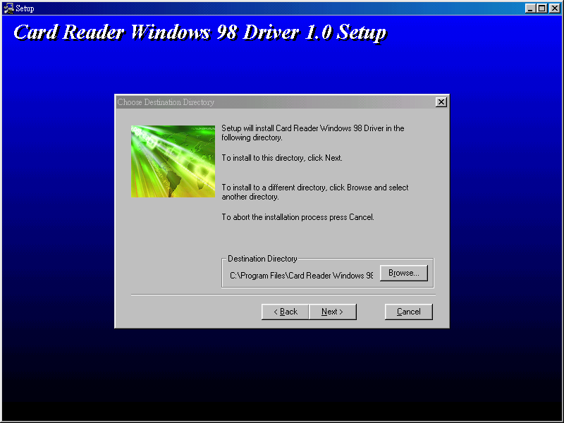

Ours Technology Inc.

- To install , click “ next> ” . Follow the on-screen instructions that are displayed on the screen.

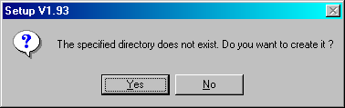

- Click “ Yes ” to install driver. Then following that are displayed on the screen.

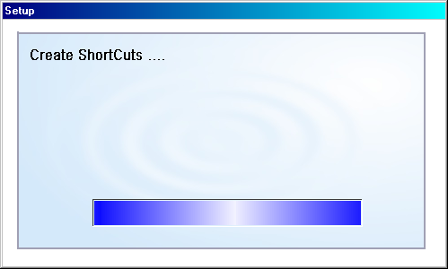

6) Finally, unplug and then re-plug the device.

